

# Matthew G. Bevin

## Governor

**TRANSPORTATION CABINET**

Frankfort, Kentucky 40622 [www.transportation.ky.gov](http://www.transportation.ky.gov/)

# Greg Thomas

# Secretary



An Equal Opportunity Employer M/F/D

To: Mr. Carey Johnson

Kentucky Division of Water 14 Reilly Road

Frankfort, KY 40601-1189

(502) 564-3410

From: <District Project Manager>

<District Address>

Date: <Date>

Subject: Notification of Floodplain Impacts

NFIP Designation

Community Name: Wolfe County, Kentucky and Incorporated Areas

Community Number: 21237C0075C (Panel 75)

Effective Date: September 17, 2008

Flooding Source: Red River

Dear Mr. Johnson.

We have investigated the floodplain impacts of an intersection improvement project in Wolfe County. This floodplain is currently designated as Zone A with no existing detailed flood insurance study for this community. This project was let for construction in October, 2014.

The proposed roadway project reconstructs the intersection of KY 3356 and KY 1010. This work requires filling and raising the roadway grade of KY 3356, which is currently located within the 100-year floodplain as designated by the FEMA Flood Insurance Study. The bridge over the Red River is outside of the project limits. A hydraulic model was developed in HECRAS to determine the effect of the proposed work on the base flood elevations. A summary of the HECRAS results is as follows:

|  |  |  |  |  |  |  |
| --- | --- | --- | --- | --- | --- | --- |
| **Wolfe County, Red River, Item No. 10‐165** | | | | | | |
|  | **Base Flood Elevation (100 year Storm)** | | | | | |
| **Section** | **Water Surface Elevation** | | | **Water Surface Elevation Difference** | | |
| **Existing** | **Mod** | **Proposed** | **Mod‐Exist** | **Prop ‐ Existing** | **Prop ‐ Mod** |
| **120134.2** | 896.44 | 896.36 | 896.39 | ‐0.08 | ‐0.05 | 0.03 |
| **119134.2** | 895.87 | 895.78 | 895.82 | ‐0.09 | ‐0.05 | 0.04 |
| **118134.2** | 895.46 | 895.36 | 895.4 | ‐0.1 | ‐0.06 | 0.04 |
| **117134.2** | 895.29 | 895.19 | 895.23 | ‐0.1 | ‐0.06 | 0.04 |
| **116134.2** | 895.14 | 895.04 | 895.07 | ‐0.1 | ‐0.07 | 0.03 |
| **115134.2** | 895.02 | 894.92 | 894.95 | ‐0.1 | ‐0.07 | 0.03 |
| **114134.3** | 894.81 | 894.7 | 894.74 | ‐0.11 | ‐0.07 | 0.04 |
| **113134.2** | 894.6 | 894.48 | 894.52 | ‐0.12 | ‐0.08 | 0.04 |
| **112134.2** | 894.45 | 894.32 | 894.37 | ‐0.13 | ‐0.08 | 0.05 |
| **111134.2** | 894.34 | 894.21 | 894.25 | ‐0.13 | ‐0.09 | 0.04 |
| **110134.2** | 894.19 | 894.06 | 894.11 | ‐0.13 | ‐0.08 | 0.05 |
| **109134.2** | 893.87 | 893.72 | 893.78 | ‐0.15 | ‐0.09 | 0.06 |
| **108484.2** |  | 893.53 | 893.58 |  |  | 0.05 |
| **108334.2** |  | 893.49 | 893.55 |  |  | 0.06 |
| **108234.2** |  | 893.47 | 893.53 |  |  | 0.06 |
| **108184.2 BR** |  |  |  |  |  |  |
| **108134.2** | 893.49 | 893.38 | 893.38 | ‐0.11 | ‐0.11 | 0 |
| **108034.2** |  | 893.38 | 893.38 |  |  |  |
| **107134.2** | 893.2 | 893.2 | 893.2 | 0 | 0 | 0 |

NOTES:

1. The existing HECRAS model was supplied by Division of Water for the current FIS in Wolfe County, dated 2008.
2. The "Mod" HECRAS model adds field survey sections to the FIS model to include an existing bridge not included in the FIS model.
3. The "Proposed" model adds roadway fill across the floodplain to the "MOD" HECRAS model to reflect the proposed grade increase of the roadway.
4. This project does not replace the existing bridge. The grade change ends prior to reaching the existing bridge.

The HEC-RAS model results revealed an increase of about 0.06 foot in the 100-year flood water surface elevation immediately upstream of the bridge. Based on these results we concluded that the impact on the floodplain elevations is minimal and is in compliance with KYTC design guidelines and FEMA regulations. Contact this office if there are any comments or questions.

Sincerely,

<District Project Manager>

Cc: <Local floodplain coordinator> Kentucky Transportation Cabinet

Ron Matar, Drainage Branch Supervisor District <XX>, Design Section

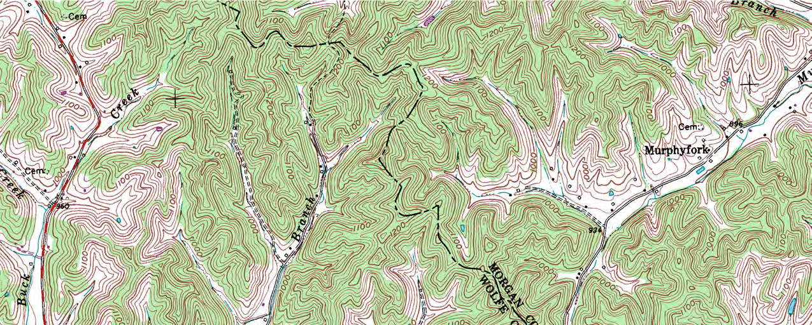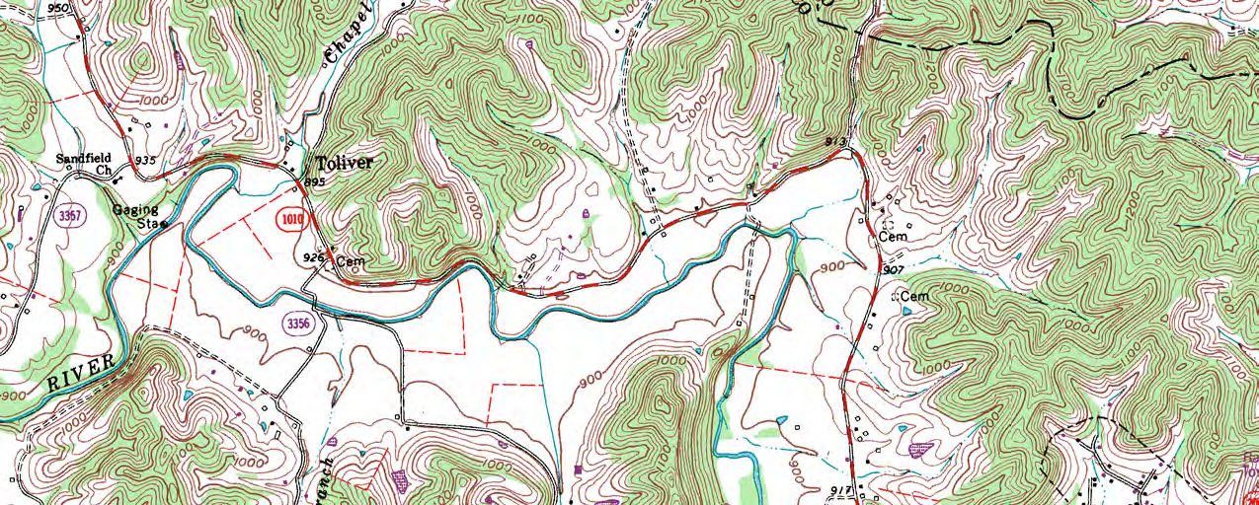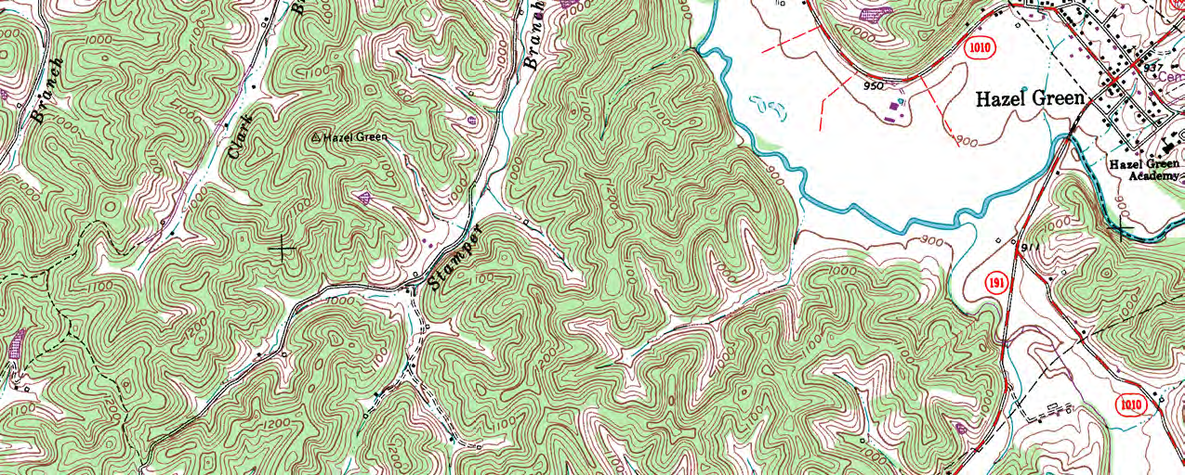

**PROJECT LOCATION**

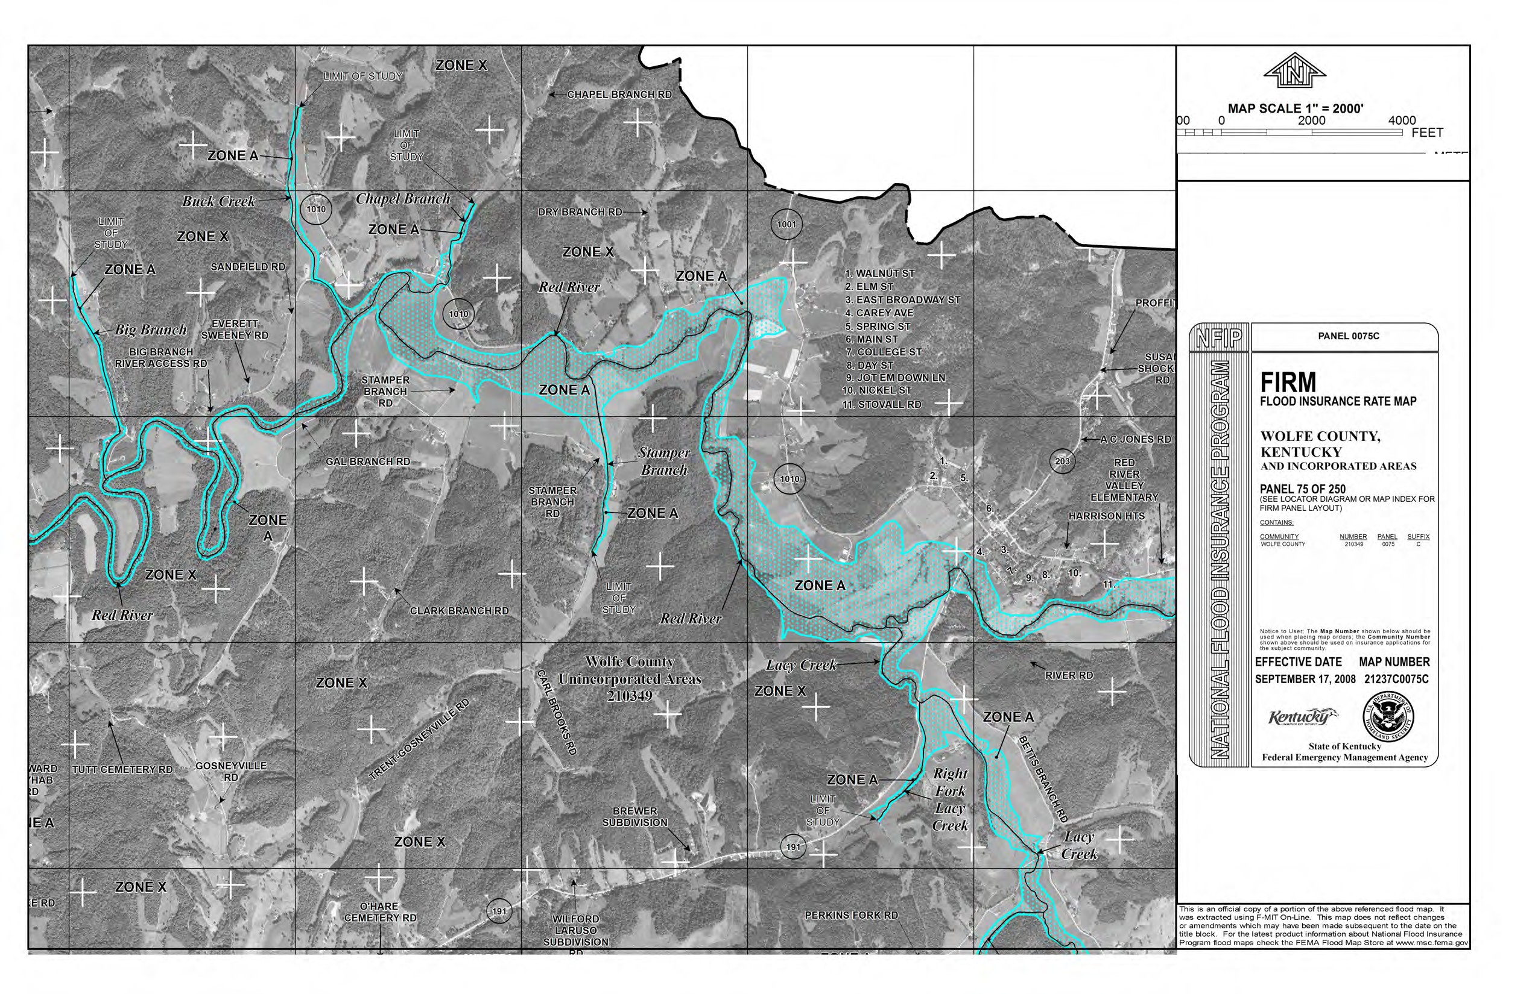

**Project Location**